Executive Summary
Ocean Carriers is an international shipping firm that focuses on operating dry bulk vessels to transport iron ore and coal across the globe. In January 2001, Mary Linn, Vice President of Finance at Ocean Carriers, was presented with a three-year lease proposal for a capesize dry bulk carrier to begin in 2003. Because the current fleet could not meet the specific requirements of the charterer, the firm had to evaluate whether to commission a new $39 million vessel to fulfill the contract. The central problem facing the organization is determining if this significant capital investment is financially viable given the company's traditional 15-year vessel lifespan policy and the varying tax implications of its New York and Hong Kong offices. Based on a 9% nominal discount rate, it is advised that Ocean Carriers commission the new vessel immediately, register the asset through its Hong Kong headquarters and extend its operational life beyond the typical 15-year policy as the vessel’s future earnings exceed its scrap value.
Summary of facts
During the negotiation, the company received a proposal for a three-year time charter beginning in early 2003, offering a daily hire rate of $20,000 with an annual escalation of $200 (Exhibit 1). As no vessel in the current fleet meets the customer’s requirements and no sustainable second-hand vessel is available, management must evaluate whether to commission a new capesize vessel at a total cost of $39 million. Specifically, the payment structure consists of 10% payable immediately, 10% due after one year, and the remaining $31.2 million upon delivery in 2003. In addition, an amount of $500,000 (with its yearly adjustment to inflation) is expected to be paid as an investment in working capital. Operating costs incurred are $4,000 per day, increasing annually with 1% above inflation (Exhibit 1). In order to ensure compliance with international regulations, Ocean Carriers incurs both annual maintenance costs and periodic capital expenditures related to mandatory special surveys. These are capitalized on maintenance costs and depreciated using the straight-line method over 5 years. Moreover, Ocean Carriers has a policy of selling its ship after 15 years in order to avoid escalating maintenance and survey costs, with an estimated scrap value of $5 million. However, vessels could technically be operated for up to 25 years. Regarding taxes, if the company was based in Hong Kong, it would benefit from a tax rate of 0% compared to the US, where firms are subject to a 35% taxation.
Statement of Problem
Mary Linn must determine whether investing in a new capesize ship to fulfill the proposed three-year charter contract is financially justified. In doing so, she considers the impact of the company’s tax location between Hong Kong and New York as well as its policy of disposing of vessels after 15 years.
Analysis
Daily hire rates are driven by the balance between demand for dry bulk shipping and fleet supply and remain highly cyclical, making the investment decision sensitive to utilization and charter rates, while operating, maintenance, and regulatory survey costs increase as the vessel ages. The ship generates revenues only for operating days whereas operating costs continue even during maintenance. To evaluate the investment, we computed the NPVs of four different scenarios using a 9% discount rate, consistent with nominal cash flows (3% inflation and costs growing 1% above inflation), and the vessel’s long life and volatile spot rates that justify a risk premium above a low-risk contract rate. We will also test its robustness by rerunning the valuation at 11%.
We will conduct the analysis on four scenarios resulting from the combination of two different factors: location (New York vs Hong Kong) and the operating horizon (15 years vs 25 years). The key driver across scenarios is taxation, with the 35% corporate tax rate in New York (U.S. statutory federal corporate tax rate for large corporations in 2001) and with Hong Kong’s corporate tax rate at 0% (the vessel’s income is treated as offshore shipping profits, not subject to taxation). If the company is located in New York, the NPVs of both 15 operating years and 25 operating years are negative (Exhibit 4). In addition, both IRRs (Exhibit 5) are below the assumed 9% discount rate, which is consistent with negative NPVs. While extending the operating life from 15 years to 25 years improves value slightly (Exhibit 4), it is still not enough to overcome the tax drag and the growing costs and maintenance burden. It is therefore not profitable to operate the boat for both 15 years and 25 years when Ocean Carriers is based in New York. If the company is based in Hong Kong, the conclusion is significantly different. As highlighted by the positive NPVs (Exhibit 4), both investment scenarios become value-creating. Both IRRs are above the discount rate of 9% (Exhibit 5), which aligns with positive NPVs. This means that the tax advantage meaningfully boosts operating cash flows and makes the project economically attractive. Also, even though maintenance costs and survey related expenditures increase with the life of the boat, operating for 25 years dominates the 15-year policy (Exhibit 4).
Nevertheless, at 11% discount rate, our conclusions become significantly more conservative. Recomputing NPVs with a higher required return turns all four scenarios negative (Exhibit 6). None of the investments would therefore be profitable using this discount rate. This is consistent with the IRRs observed in the base case because once the discount rate rises above the project IRR, NPV becomes negative.
Recommendation
If choosing a 9% discount rate, Ocean Carriers should commission the new capesize vessel only if the project is structured under the Hong Kong tax jurisdiction. Furthermore, it would be economically advantageous for the company to operate the vessel for its full 25-years useful life, hence changing its current policy. However, the stress test shows that the recommendation is highly sensitive to the assumed cost of capital, as the investment should be rejected if 11% is the discount rate.

Exhibits
Exhibit 1: Operating Assumptions and Cost Structure
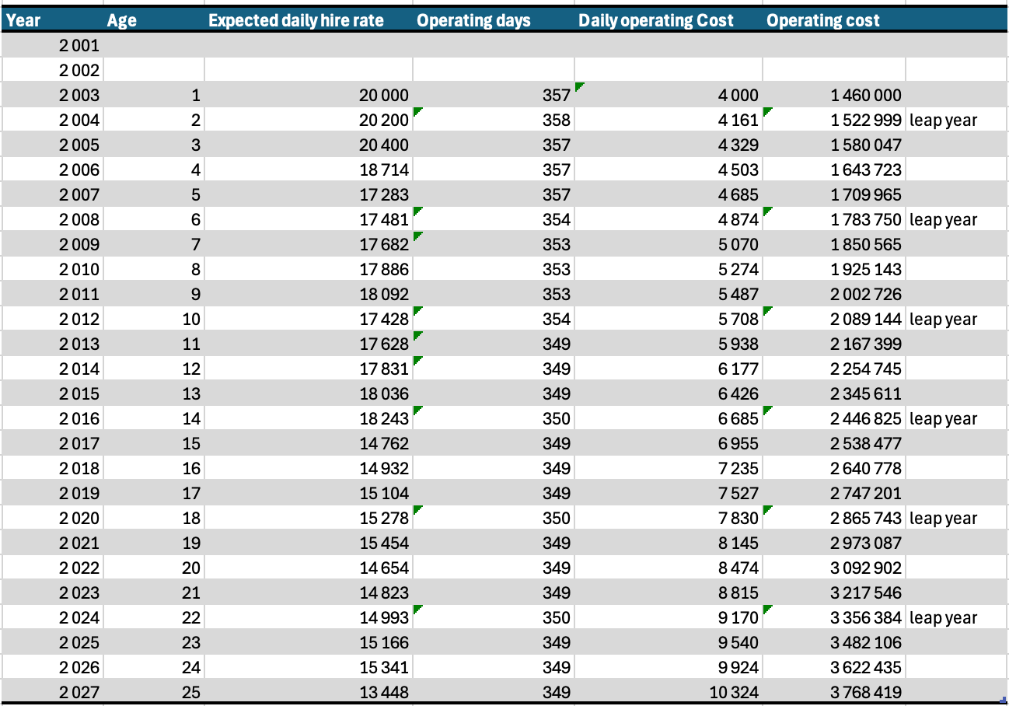
Exhibit 2: 25-Year Cash Flow Projection (Hong Kong and New York)
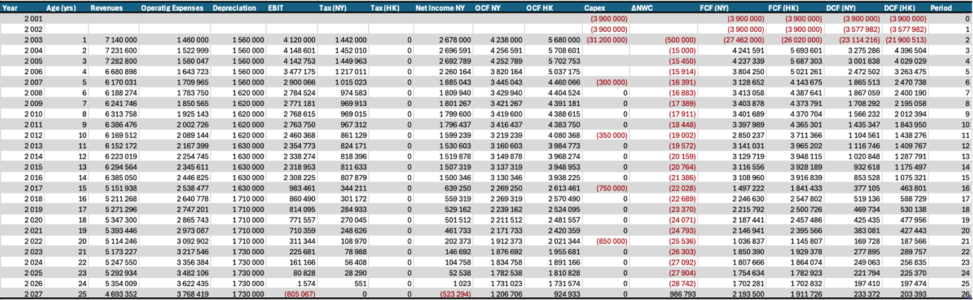

Exhibit 3: 15-year Cash Flow Projection (Hong kong and New York)
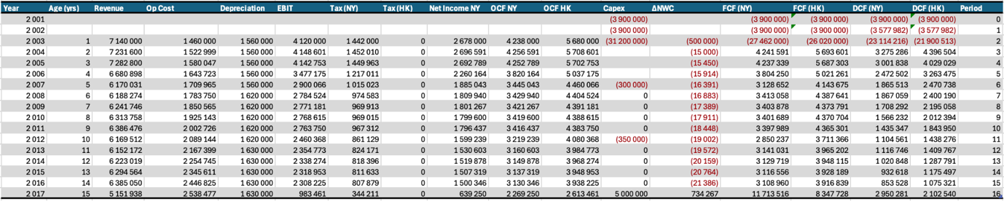
Exhibit 4: NPVs under different scenarios – 9% discount rate
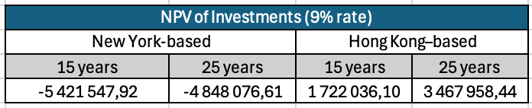
Exhibit 5: IRRs under different scenarios – 9% discount rate
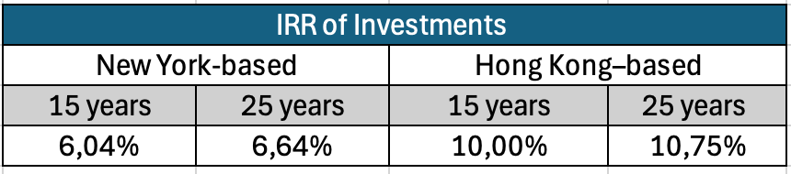
Exhibit 6: NPVs under different scenarios – 11% discount rate
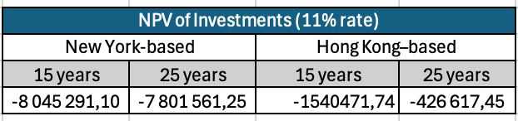

Footnotes and assumptions
- Scrap value (15-year case): The $5,000,000 scrap value is added to the cash flow of the terminal year (2017).
- In the 15-year New York case, scrapping the vessel generates a disposal loss that creates a tax shield of $3,710,000, treated as a terminal-year cash-flow benefit at the corporate tax rate.
- Expected inflation is assumed constant at 3% per year over the horizon.
- Net Working Capital (NWC) is defined as Accounts Receivable + Inventory − Accounts Payable, an initial $500,000 NWC investment is made at vessel delivery (2003), assumed to grow with inflation (3% annually), and is fully recovered at the end of the operating horizon (15 or 25 years).
- Daily operating costs increase at 4.03% per year, computed as (1+0.01)(1+0.03)-1 = 0.0403 (4,03%)
- All payments occur at year-end, including vessel purchase payments.
- Spot (market) daily hire rate forecasts used after the initial charter period are taken from the case exhibits and assumed reliable for projecting post-charter revenues.
- Counterparty default risk on the initial 3-year time charter is assumed negligible (no early termination / non-payment).
- Leap years are explicitly accounted for in the operating-day count where relevant.
- The vessel is depreciated on a straight-line basis over 25 years.
- The residual value at the end of the vessel’s useful life (25 years) is assumed to be zero.
- No interest is incurred or paid; therefore EBT = EBIT.
- Annual free cash flow is computed as: FCF = NI + Total Depreciation - Δ NWC - CapEx
- Special-survey capital expenditures are assumed incurred at year-end (December), consistent with the annual timing convention.
- Cash flows are discounted using a 9% nominal discount rate (base case) and 11% as a stress test.

